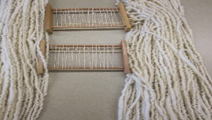Weaving the Literacy Blanket: Caring Adults Pass on the Legacy of Literacy
Written by Donna Klockars for “Reflecting Together- Strengthening Practice Conference” March 10, 2018
Stz’uminus Community School
Just like talented weavers, caring adult literacy mentors use foundational strands to create a beautiful literacy blanket, unique for each child. This “blanket” provides life-long use for future learning. Three important strands are needed to weave a strong and serviceable literacy blanket for our very young language/literacy learners.
Strand#1: Nurturing and Sustaining the Literacy Relationship
Parents, aunties, uncles, grandparents, elders, teachers, family friends, and community members can all act as literacy mentors. We know that starting out right is important. Children begin their literacy journey while they are still very young. Parents and other literacy mentors help children develop language and literacy skills by casually pointing out meaningful words or letters. They take time to explore unique and individual connections when talking and reading together. They expand on phrases such as “this book reminds me of a time”, or “I wonder why ...,” or “this story is just like when ...”. When a caring person thoughtfully turns book reading into talking time, the child knows they are valued, and that someone cares about the important events in their young life. The reading time is a positive experience, because the adult is playful, and enthusiastic. The caring adult searches for books that are of interest to the child. They find books and oral narratives that reflect the child’s culture. They allow lots of time for “grand conversations” to naturally unfold while reading together. The very young reader connects “book time” with feeling safe and loved. No literacy program exists that replaces caring literacy mentors in a child’s life. The relationship fostered between book, child, and caring adult leads to children engaging with print for the sheer joy of it.
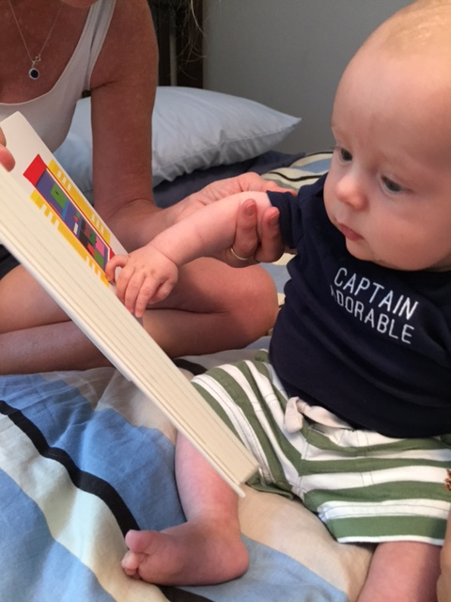When children’s books are viewed as opportunities for conversations, and when words are presented so that they sparkle and shimmer with meaning; we are weaving the child his or her very own Literacy Blanket. Most importantly, the positive relationship created between adult and child through sharing simple texts, can prevent reading failure!

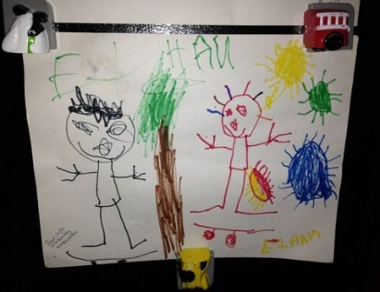Strand# 2: Nurturing and Sustaining Understandings about How Books and Print Work
Building the child’s knowledge about print, means that we provide play-based learning opportunities that explicitly reveal how books work. We help them recognize “story-telling” structures by providing playful situations where they can easily respond to stories. Providing story baskets that are filled with artifacts from a favourite text, invites children to act out the story. Using simple props, groups of children practice new language structures from the story and expand the ideas that they remember. Story baskets are an example of how caring adults help the very young, understand that stories are about a sequence of “happenings”.
The thoughtful literacy mentor is ever mindful that children learn through play. They provide fun and inviting activities that are connected to the story. The simple picture book, In Went Mouse, can be a way to explore language concepts such as the position words “in and out”. A familiar story provides opportunities to practice new ways of talking and sharing new ideas.
Consolidating the concepts about story structures, viewing the many purposes for print, developing word knowledge, providing play opportunities to negotiate the difference between “spoken” and “written” language, is a long, gradual and complex learning process. Children need many opportunities to explore and discover how squiggly black lines (printed words) are just like talking. Early literacy learning is similar and closely connected to learning to talk, but not the same.
Recent research supports an interactive and experiential process be used to help the very young master language/early literacy learning. When educators and parents invite children to explore print, children will naturally construct, and refine their understanding of how print works.
Pointing out how letters correspond with certain sounds, and that words can be broken apart and put back together again can be revealed via an engaging story, song or poem. Even very young children enjoy listening for rhythm and rhymes in the story. When the “just-right” text is shared, it helps the child notice that readers use a left to right sweep across the page, that words have a certain sequence of letters, and they observe how pictures support the story. The thoughtful adult creates and guides the very young. They create learning opportunities that reveal how print works in a playful and relaxing environment.
Making meaning from black squiggly lines is complex. Quality coaching is essential. Every minute with a capable and caring literacy mentor or coach is precious. Caring adults who guide early language/literacy learning, are motivated to celebrate the riches found in children’s literature. They create a time and a space for language building opportunities that “just-right” books can offer.

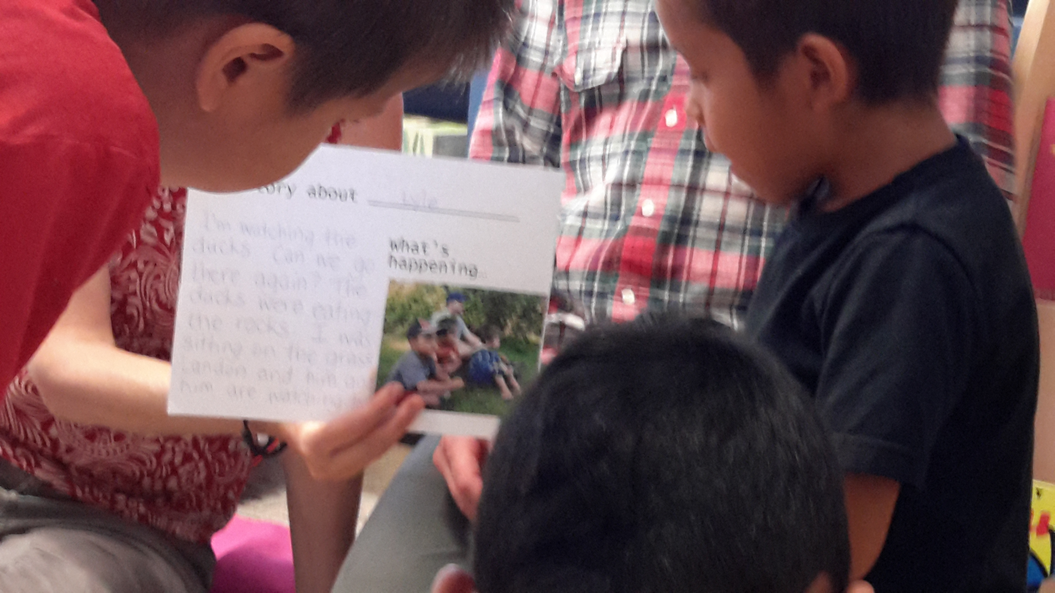 Strand#3: Nurturing and Sustaining the Love of Reading
Educators must also pay attention to the interests and strengths of each reader because high interest in a topic enhances comprehension and motivates the young reader. Book language is often different from the language we use in general conversations. Fostering awareness and understanding of the language found in books, (especially non-fiction) is difficult because unfamiliar syntax and abstract vocabulary is often presented.
Children benefit when caring adults provide a diverse selection of texts for the child to explore. The texts should be culturally relevant and honour the unique strengths, interests, and gifts of the child. The very young, enjoy and learn from literature that presents characters and settings that are easily recognized. Children learn ways of addressing their own fears, challenges and real-life issues when they get to know a how a character solves problems in a story. A good story can help a child better understand his or her feelings and frustrations. It also provides ideas and modeling for “self-regulating” behavior.
Frequent opportunities for “talking time” connected to familiar stories, encourages the child to respond, reflect, and think critically about the story. Our most practical and effective opportunity for nurturing the very young to become self-motivated, independent readers, is to read to children every day. Three stories a day, that is the minimum, not the maximum!

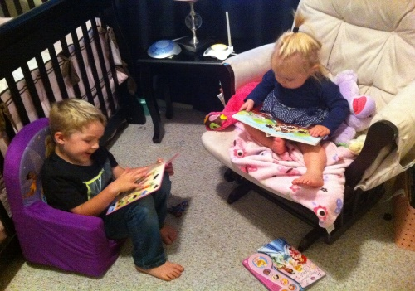Early Literacy Does Not Mean Early Formal Reading Lessons
Our current understanding of early language and literacy development has provided new ways of helping children learn to talk, read, and write. Just like oral language development, early literacy is a continuous developmental process that begins in the first years of life. However, current research DOES NOT advocate the “formal teaching of reading” to the very young! Formal instruction, where infants, toddlers or pre-school children are cued to read words, is not developmentally appropriate. However, interactions with “just-right” texts and play-based activities designed to explore a story, promote the natural unfolding and mastery of early literacy skills.
Those first five years, where caring adults support the very young to explore and play with books is important. When we sing nursery rhymes, provide repeated exposures to engaging texts, point out important letters and meaningful words in familiar environments, expand stories during dramatic play, encourage children to draw, scribble, and pretend write; we establish oral language and early literacy. These early language/literacy skills are essential to later success in school. The adult literacy mentors “show the way to literacy success”. The literacy mentors and the child walk hand in hand. The caring adult’s mentorship role in providing play-based, learning opportunities contributes to a joyful literacy journey.
When you provide the important language/literacy strands for the very young, you create a unique Literacy Blanket that ensures that the child will succeed. No one can replace you. The young people you care about will become strong readers and thinkers- because of you. Remember, caring adults like you, pass on the legacy of literacy.
Donna Klockars, March 2018

