Teaching Strategies and Graphic Organizers that Support the Reader: “Before, During and After” the Read

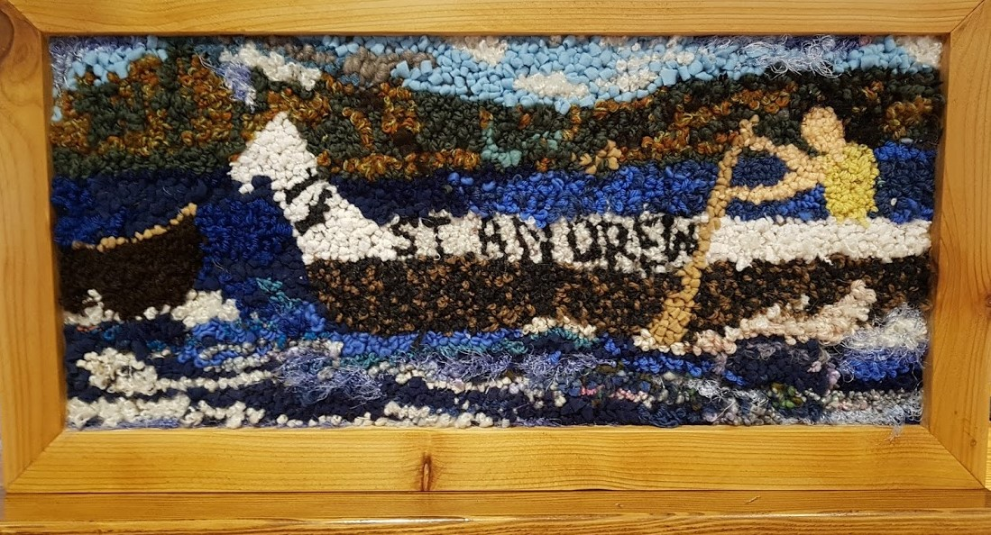

Rug hooking by Donna Klockars

Written by Donna Klockars
Table of Contents
Graphic Organizers and Teaching Strategies

Materials that support students building background knowledge, accessing prior knowledge,
Brainstorm KWPLHT Chart
Taxonomy Book Mark
ABC Brainstorm for Words or Phrases
Anticipation Guide
Artifacts in a Bag: Pearl Harris Story
Double Bubble Map
How to Use Pictures as Text or “Reading the Pictures”
Vocabulary Scramble
Vocabulary Building Book Mark
Vivid Vocabulary in the Shapes
Word Bank Sorting from the general account into the proper accounts
Word Sorting for Vivid Vocabulary: Word Lists from Frog Girl
Word Bank Prediction Activity for “Wild Woman”
Using Text Features to Support Your Learning

Processing Strategies that Support the Reader in Making Meaning
GRASP: Monitoring understanding of textual Information
Double Entry Journal and Prompts for Different Purposes
People Puzzle
Character Outline
Four Squares and a Rectangle Thinking Page
Strategies that Transform and Personalize your Learning
Student Created Reading Response Worksheet
Setting Criteria for a Powerful Descriptive, Narrative, Persuasive, Comparison Paragraphs
Persuasion Framework for a Debate or an Academic Controversy
Who am I Riddle Box
Cube It Story Summary
Having a Tea Party while Playing a Role from the Text Set

Strategies that Support the Reader

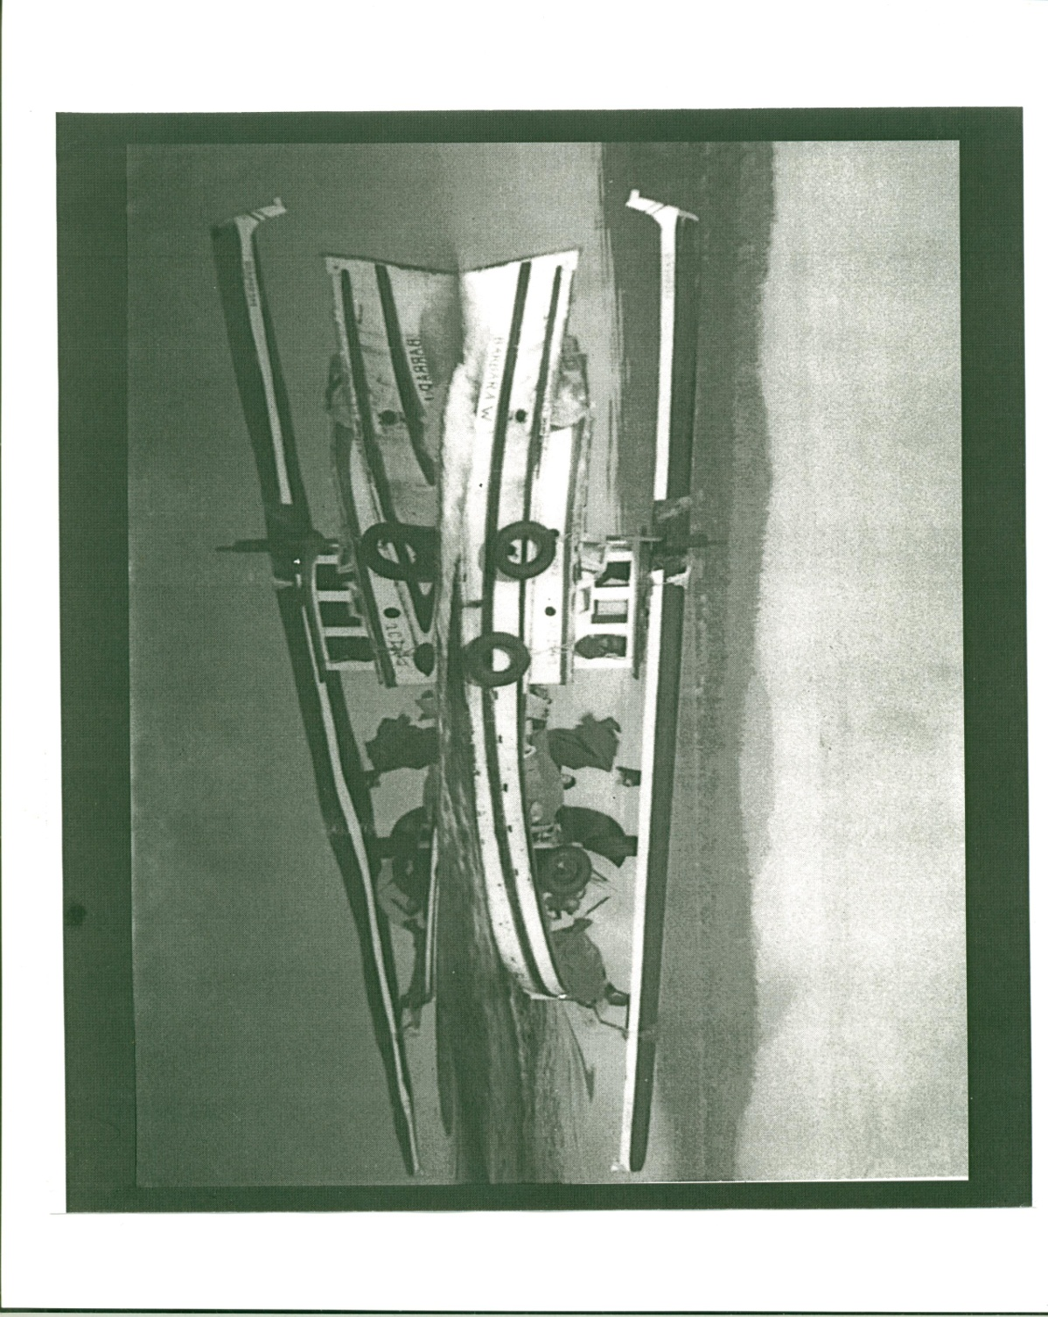
Transporting the St. Andrew to the Race

Young Pearl Harris enjoying a sunny afternoon at Kulleet Bay

Read the Art

Describe who is in the pictures.

What is happening? What was being said and done before the picture was taken?

Where and when was this picture taken? (Conjecture is O.K.)

Why do you think the picture was taken? Why was it chosen for this book?

If you were the subject of this picture, what would you be thinking?

Describe something of interest to you in this picture.

My best “story predictions” created from this illustration.

K W P L H T Brainstorming Chart

What I Know  about historical fiction & traditional myths of the Aboriginal, Metis & Inuit | What I Want to know | What I Predict  we will encounter/learn about this time in history
What we Learned | How We learned | What I used to Think but now I Think

ABC Brainstorm

A | N
B | O
C | P
D | Q
E | R
F | S
G | T
H | U
I | V
J | W
K | X
L | Y
M | Z

Strategy: ABC Brainstorm

Before having your students talk about a major topic, it is essential to activate their background knowledge about it. One way to do this is the ABC Brainstorm. The idea is meant to be fairly simple. Students try to think of a word or phrase associated with the topic, matched to each letter of the alphabet.
Have students list all the letters of the alphabet down a sheet of paper, leaving room beside each letter to write out the rest of a word or phrase. Let them work individually at first, thinking of as many words as they can that could be associated with the topic you identify. Do note: The topic should be big and general enough that students can actually think of a lot of possible terms. Then, in no particular order, let them begin filling in the blanks beside each letter of the alphabet.
Give students enough time to think of a lot of ideas, then let them pair up or work in small groups to fill in blanks for letters they had not yet completed. In this way, you can let the brainstorming function like a Think-Pair-Share. This would be the “Pair” phase. Then, go around the room or get students to report out (“Share”) possible terms for the different letters of the alphabet. Another extension of this activity is to request that the teams identify the two words or phrases that most aptly summarize the topic. (Two Word Summary)
Examples:
- War Canoe Racing
- The Stz’uminus Territory
- Writing in Role for a Character called….
- Kuper Island Residential School

“Before the Read” Predictions

Name:________________________ Date:________________

Book Title:_____________________________________________

Artifacts that I think Provide Clues from the Story Bag
Clues from the Title
Clues from the Cover

My Predictions About this Fiction/Non-Fiction Based on Clues and my Background Knowledge on the General Topic

“VIVID VOCABULARY” IN THE SHAPES ACTIVITY

Choose “Vivid Vocabulary” from Text Set for Stz’uminus Inquiry - Non-fiction or fiction in the first seven lines of each column. Now use the spelling strategy called “Look-Cover-Write-Check” for each of your Vivid words.
LOOK; COVER WRITE; CHECK LOOK; COVER WRITE; CHECK

____________ ____________ ____________ ____________
____________ ____________ ____________ ____________
____________ ____________ ____________ ____________
____________ ____________ ____________ ____________
____________ ____________ ____________ ____________
____________ ____________ ____________ ____________
____________ ____________ ____________ ____________
____________ ____________ ____________ ____________

- Which words are only in the triangle? ____________________________
- Which word is in the circle and the triangle? _______________________
- Which word is not in the circle, triangle, or rectangle? _______________
- Which word is only in the triangle and the circle? ___________________
- Which words are in the circle, triangle, and rectangle? _____________
- In which shape is the word ____________________________________
- Which word is only in the triangle and rectangle? ___________________
- Which shapes have both the words ____________ and _____________?
- Write ____________ so that it is in the triangle and the circle.

Create a sentence using three words that you find in only the triangle
_________________________________________________________________
- Create one question using two words found in only the rectangle.
__________________________________________________________________________________________________________________________________
- Create a whopper sentences using four of the words found in only the circle, triangle, and rectangle.

Word Bank Prediction Activity
What words do you think belong in each category?
Words List from Wild Woman
- Lumbered- sparks transformed into birds
- Stomped through the valley
- Ear flaps-greasy hair very grateful
- Stz’uminus Mountains
- Constant hunger beaches of Kulleet Bay
- Giant cedar basket
- Go to bed without any fussing
- Catching bullheads wild dancing
- Daylight vanished
- Scoop up the children- make a fire-
- bruided and jossled
- Lurching and crashing feast
- Little sister-little children twigs woven into her cape
- Twirled and stomped
- Tripped and fell greasy black hair
Characters | Setting | Plot  Problem / Solution
We think this story will be about
________________________________________________________________________

________________________________________________________________________

________________________________________________________________________

________________________________________________________________________

________________________________________________________________________

- Key Sketch

WORD BANK
DIRECTIONS: Deposit all the key words or concepts into the general fund then “Withdraw” the words from the ‘General Fund’ and ‘deposit’ them in the proper account below.
 | Words from The Land Grab
Piracy | Pacific Ocean | Grave sites
Colonial theft | Assault | Cultural site
Land grab | Hul’quimi’num | Vancouver Island
Cowichan | Denying | Fort Rupert
Lake Cowichan | Hwulunitum
Unremitting decline | Settlers
Prosperity | Sir James Douglas
British Columbia | 45000 acres
Invisible stain | Unremitting decline
Alienation | Chemainus
Nanaimo
Words that impart a strong message | Words that might be on a map | Persons or Places | Activities | Types of land

Word Sorting for Building-Vivid Vocabulary
Words with three or more syllables | Words that are proper nouns | Words with common word families | Words with double consonants
Words that are compound words | Words that are contractions | Words that are descriptive or describing words | Words that are action words
Words that have a base + suffix or prefix | Words that describe the main character | Words that are WOW words | Words that are vivid words
Words that I don’t know | Words that are my present favourites

Using Text Features to Support Your Learning-
Text Features | What I Predict  I Will Find Out | My Thinking About This Text Feature
- Cover

- Map and legend

- Bold Words

- Headings

- Did you know box

- Read the photographs

- Speech bubbles

- Glossary

- Index

- The layout for the text
- Use of colour  - ______________________  - Other text features | ________________ | ________________

Two Powerful text features are ____________________________
and _________________________________________________.
They helped me understand what I read because________________

I can create at least two questions by converting a caption or heading into a the question from or into a I wonder statement__________________________________________________________________________________________________
I can create an information text that effectively uses at least six of the best text features. Examples of written work that would show what you know about text features:
A pamphlet on War Canoe Racing
An article on how to create a Dug-out canoe
An information blurb on Shellfish Management and traditional Teachings
Write something that attracts young people to the field of teaching
Your choice…Remember that Text Features are used to enhance the understanding of the text content.

X YZ
Taxonomies:
Alphabetical lists of terms related to subject or topic.
Prompt: On the topic of____________________________________________, I would like to contribute these terms that I know.
Purpose:

This activity reinforces the concept that words are free. Work individually, then meet with a learning Partner and add new words to your list.

Purpose of Personal Taxonomy
- Organizing Prior Knowledge
- Continuous Note taking
- Vocabulary Building
- Adding to New Knowledge (Schema)
- Building on Cooperative Learning Experience
- Getting Started with Writing Goals

Anticipation Guide:

Name: ________________ Date: ___________

Topic:
Before Reading |  | What Do You Think? | After Reading
Agree | Disagree |  | Agree | Disagree
 |  | .

Work in pairs to write ten facts and three false statements about your area of expertise. Ask your peers to complete the Anticipation Guide before they read a passage of text about the chosen topic. Distribute reading material on your topic to your peers After the read, discuss your topic.

Traditional paddle
Broken Heart
Artifacts: What will this story be about?
Make Predictions for Pulling for Stz’uminus: The Pearl Harris Story after viewing the artifacts and the book cover with a
partner.

Trophy
Canoe Pictures

I think the story will be about:

_____________________________________________________________________________________________

Marsh/Grasses, etc.

Bag of Soot/Ashes

Frog Puppet

Frog Girl
Using the Story Bag to Predict and Tell the Story

Bentwood Box

- small wooden one or one made from a“cube” template

Button Blanket with Frog Crest

Volcano Pictures

I think the story will be about: __________________________________________________________________________________________________________This is what I think will happen______________________________ _____________________________________________________ This is how I think the story will end_________________________

DOUBLE BUBBLE MAP

Pearl Harris
Story

Tom and the Blackfish

Making Text to Text Connections
Show what you know about the two narratives. How are they different? (Outside circles) How are they similar? (Middle circles). Add your connections using additional circles. Additional connections can be shown by linking one bubble to another with a line. Record your thinking about the connection on the line. Share your thinking with a learning partner and add new connections. Conversations with your learning partners “grows your schema” about the characters. Be sure to thank your colleagues for their contributions to your Mind Map.

Close Up of an Illustration-Finding and Reading the Information in a Photograph so you can “TALK ART”
Describe who is in the picture. Use all the descriptive language you can. Notice all the details the artist or photographer has used to convey information about the character or story line.
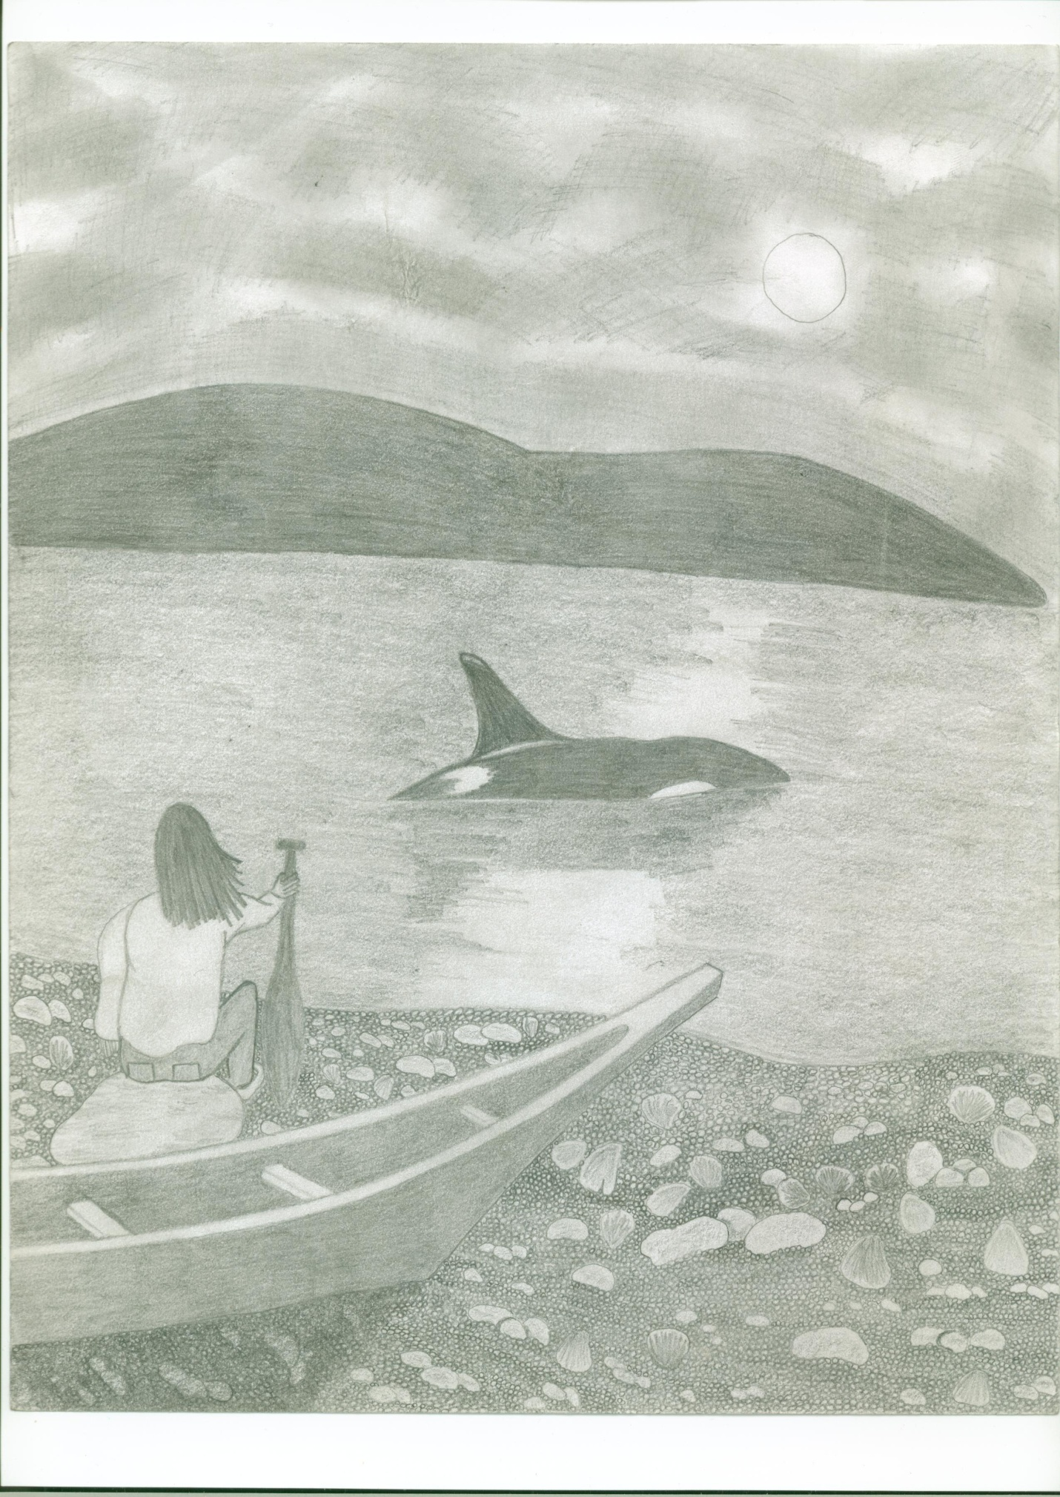

What is happening? What was being said and done before the picture was taken? (Predict the dialogue that you imagine is or could be happening.)

Why do you think the picture was taken? Why was it chosen for this book?

If you were in this picture how would you describe the colours and textures that you sensing/touching?
If you were the subject of this picture, what would you be thinking?

Describe something of interest to you in this picture. Perhaps you wonder about something or you are reminded of something or some time in your own life.

What background knowledge do you bring to the “viewing of this picture? Has your background knowledge plus the evidence available in the picture suggested some inferences?

This illustration triggers these ideas.

Finding Information in a Photograph

Describe who is in the picture.

What is happening? What was being said and done before the picture was taken?

Where and when was this picture taken? (Conjecture is O.K.)

Why do you think the picture was taken? Why was it chosen for this book?

If you were the subject of this picture, what would you be thinking?

Describe something of particular interest to you in this picture.

My best story gist I created from this illustration goes something like this:_________________________________________________

____

Vocabulary Building
Bookmark
Book Title

__________________________________

Vocabulary Building
Bookmark
Book Title

__________________________________

Key sketch

Key sketch

Brainstorm Mind Map
Show the Big Idea, related topics and details that support the topics. Use this information to create your paragraphs.

Don’t forget to identify the type of paragraph you are writing. Each type has particular features, but all must have a good lead sentence (a hook), related supporting details and a summary sentence that wraps it all up. Think about the hamburger analogy.

Vocabulary Scramble
1. Example

Clues: ________________________________________________________________________________________________________
Word:____________________
2. Example

Clues: ______________________________________________________
_______________________________________________________________ Word: __________________________________
3. Example
Clues: ______________________________________________________
_______________________________________________________________
Word: __________________________________
4. Example
Clues: ______________________________________________________
______________________________________________________
______________________________________________________
Word: __________________________________

GRASP (Gear Up, read, Ask, Summarize and Predict)

(Modified Reciprocal Teaching)

Purpose: to enable students to monitor their understanding of textual information in an active and planned way. GRASP teaches students to be self-aware as they read fiction and non-fiction materials, to grasp ideas that they understand, and to work on ideas that are elusive or difficult.

Process:
- Students work through a five-stage process of self-checking their comprehension as they read:

- Gearing Up: Students survey the text, looking at illustrations, charts, titles, the last page of the previous chapter, and so on.

- Reading: Students read and flag difficult ideas and vocabulary.

- Asking: Students ask questions to clarify the meaning of new words or difficult concepts.

- Summarizing: Students summarize the selection to include the important points.

- Predicting: Students predict what will occur next. Predictions are based on previous reading in combination with personal experiences.

In class strategy lessons, the teacher models the techniques and asks students to participate in the process. Student participation should increase over time. The magazine articles about the Kulleet Bay conflict in September,2010 issue Stz’uminus newsletter or an overhead transparency of a text could be used for shared reading. The Hul’quimi’num Land Grab would be an excellent booklet to present as a mini-lesson where the teaching team introduces and models this strategy. The reciprocal reading strategy has been around since 1945 and is well established as a way for students to understand process information text that has a fair amount of new content.

- Students should be asked to GEAR UP by looking at the charts, pictures, titles, and headings. They discuss these elements to make hypotheses about the text they are planning to read together.

- A section of an article can be READ orally, with students suggesting difficult words and concepts to underline for further consideration. The teacher can model using sticky notes to ‘flag’ textual difficulties, a strategy that students can use when reading independently.

- The teacher then models ASKING questions about the new words and difficult concepts, and the students are invited to add and explore their thoughts through discussion.

- The teacher models SUMMARIZING the selection and stresses the importance of recalling the important information before continuing to read.

- The final stage of a demonstration is PREDICTING what will happen next.

Source from Pearson’s Literacy Place-Notes by D. Klockars

PROMPTS FOR DIFFERENT PURPOSES
Making Personal Connections

- What did the story remind you of?

- Tell about at least one connection that you can make personally with the characters or story. Do you have some shared interest, feeling, or experience? Are you like or different from one of the characters?

- What kind of reader would like this book?

- Is there any character in this story/book like you? How is this character like you?

- Is there a character in this story/book who would make a good friend?

- Compare at least two characters to yourself, your family or your friends.

Identifying Important Elements

- What are one or two of the most important ideas from this story?

- What was the author trying to tell you about life with this story?

- What do you think was the most important or most interesting part of this story?

- Who do you think was the most important character? Why was this character important?

- As you get into your novel, you should get to know the main character. Describe the person physically, but also give examples of how she or he feels and what she or he does.

- Choose a character in the book who is important but not the main character. Describe this person, explain or her relationship to the main character, and tell why she or he is important to the story.

- What surprised you in this story? Why was that a surprise? What did you expect instead?

- Does the title fit the story? Why or why not?

Source: Graham & Speigel, 1996; Writing and Thinking in Response to Literature Circles, Chapter 4, pp 98-99.

PROMPTS FOR DIFFERENT PURPOSES
Noticing the Author’s Craft

- If the author of this book were in our classroom right now, what would you say to or ask this person?

- If you could change this book, how would you change it?

- Is anything in this book strange or weird? Why do you think the author put that in the story?

- Did the author write this book in a special way (for example, lots of visual images, flashbacks, told in the first person)? Do you think that made this a better story?

- Why do you think the author wrote this story?

Expressing Feelings about the Story

- How did the story make you feel? Tell what parts made you feel this way.

- Why do you think other students might or might not enjoy reading this story/book?

- Would you recommend this book to someone else? Why or why not?

- Would you read another book by this author? Why or why not?

- What was going through your mind as you read this story?

- What was your favourite part of this story? Why is that your favourite?

- Which character did you like best or least? Why?

- Did your feelings change as you read this story? How?

Source: (Graham and Speigel, 1996) Taken from Chapter 4: Writing and Thinking in Response to Literature Circles, pgs. 98-99.

Source: Graham & Speigel, 1996; Writing and Thinking in Response to Literature Circles, Chapter 4, pp 98-99.

Prompts and Probes

Prompt: | Have you ever felt like this character?
Probes: | How does the character feel?  Have you ever felt like this?  What does/did the character want or hope or need?  How are your experiences the same or different?
Prompt: | Would you read another book by this author?
Probes: | What were your favourite parts?  What did those parts have in common?  Did you like the main character?  Did you care what happened to him or her?
Prompt: | What questions would you like to ask the author?
Probes: | What didn’t you understand?  What parts seemed strange to you?  What parts didn’t you like?  Why do you think the author wrote it that way?
Prompt: | What was the author trying to tell you?
Probes: | What were some of the things the main character did?  What happened to them?  What were the results of their actions?
Prompt: | Do you think the main character did the right thing?
Probes: | What things did he or she do? (Brainstorm a lot of them.)  What other options did he or she have?  What do you think the consequences would have been if he/she had done something else?
Probes that work with almost any prompt:
Why do you feel that way?
What examples from the book made you think that?
How does that connect to what we were talking about before?
Source: Graham & Speigel, 1996; Writing and Thinking in Response to Literature Circles, Chapter 4, p. 102

Double Entry Journal
Rationale:
The Double Entry Journal allows the student to respond to their reading in a personal way and gives them a focus or a purpose for their Silent Reading
Steps:Introduce the types of Double Entry Journal Responses, one at a time.
Types of Double Entry Journal Responses:
a) What happened  b) Two events  c) Quotation from the text | My thinking  My thinking about these events  My Interpretation/Thinking of the meaning of this quote
At the beginning of each lesson, show the students an example of a Double Entry Journal Response.
Respond using a novel that all students are currently listening to or reading.
After all three types of Double Entry Journals have been introduced and practiced, let the students choose an entry they will use when responding.
Occasionally a student will need to be encouraged to try a different Entry Type, as some like to describe only what has been happening.
WATCH OUT FOR:
  - Students may spend more time copying down a quote or describing an event and run out of time for their thinking. At first, I often need to limit the time the students can spend on the first part of their Journal Entry so they will have enough time to write a well thought out response.

  - I do not always have the students divide their page in half. I often have them write the quote at the top of their page and respond under.

  - Choosing two events that are connected is often difficult. At first, the students will choose two isolate events and respond to them. Doing an example from a book that I am orally reading really helps with the understanding of this activity.

Double Entry Journal
Prompt:

What happened? What I think about what happened
____________________________ ___________________________
____________________________ ___________________________
____________________________ ___________________________
____________________________ ___________________________
____________________________ ___________________________
____________________________ ___________________________
____________________________ ___________________________
____________________________ ___________________________
Prompt:

What happened? What I think about this. t____________________________ ___________________________
____________________________ ___________________________
____________________________ ___________________________
____________________________ ___________________________
____________________________ ___________________________
____________________________ ___________________________
____________________________ ___________________________
____________________________ ___________________________

The 3 R’s Retelling Strategy Information
Our reflections are the making of deeper meaning and richer understandings: Our reflections are our dreams, our ideas, our questions, our initiatives, and our vision – our journeys of lifelong learning and teaching.
We have found it very effective to invite learners, through modeling, demonstrating, and questioning, to respond, think, and reflect. For example, in a read-aloud situation, when we are involved in reflecting we might say or think: Always helping students recognize behaviors that Good readers use.
I wonder how…
- I wonder if…
- I wonder why…
- I wonder when…
- The part about ____________ really interests me. I think I will…
- This gives me an idea to….
- Why do you think…?
- What do you think about…?
- I think that…
- Now I understand that…
- I want to…
- This reminds me of…
- This makes me feel
- I noticed that…

Source: Benson and Cummins, The Power of Retelling, 2000

You may wish to create a poster by enlarging the 3 R’s circle “Reflect,” and post it as a reference chart for your learners to refer to as necessary, or you can make it into an overhead transparency for a large group lesson, or you may want to hand out copies to the learners and guide the students through the strategy.
Inviting learners to retell keeps them tied to what they have been told, have experienced, or have read without moving them beyond the basic information and comprehension level. When we invite learners to relate and reflect, we expect them to elaborate, explain, and expand their knowledge and understanding. By fostering and valuing higher order thinking, and developing deeper understandings, we nudge learners beyond the basic levels of thinking.
There is no one way to model, demonstrate, or share retellings, relatings and reflections. Many strategies and techniques need to be explored to enable learners to demonstrate their relatings and reflectings.
Just as conversations and connection are interactive and circular so is the 3 R’s framework. Retelling, relating, and reflecting do not necessarily occur in any specific order when we listen, speak, and learn. Sometimes we begin our conversations by sharing our memories (relate).
Other times, we share anecdotes or artifacts (retell) and begin speaking by questioning or wondering (reflect).

Source: Benson and Cummins, The Power of Retelling, 2000

The 3 R’s Framework
This is about…
I notice that…
I especially like…

Reflect

Reflect

This connects with… I am wondering about…

This reminds me of a story… I have an idea to share…
This reminds me of… I wonder if…
It makes me think of… I wonder why…
It makes me feel that… What do you think about…?

Source: Adapted from The Power of Retelling, by Benson and Cummins, 2000
The 3 R’s Framework for a Response Journal

Goal: To write powerful journal responses to the various versions
of the “story about Seagull Steals the Sun or Raven and the Moon etc.
Establish criteria for a powerful journal entry.
- Evidence of completing the 3 R’s framework of retelling, relating, and reflecting. Complete the framework on back of this sheet.
- Sophisticated vocabulary.
- Include all of the elements of a story frame.
- Comparisons – between characters, between similar stories, etc.
- Evidence of conversation with the author.
- Social concerns or connections to social issues.
- Include the “I wonder why….”
- Opinions proven facts with evidence from story or life.
- Work has been edited using C.O.P.S. strategy.

Performance Scale

- powerful: 5 criteria are througtfully met. Your response flows and sounds like a conversation.

- 3 – 4 of criteria are met. You have written your opinions/personal feelings but with less support.

- Less than 3: developing of the criteria are met, opinions not present, no fluency.

Source: Adapted from Benson and Cummins, The Power of Retelling, 2000

PEOPLE PUZZLE

Character Trait:  ________________  Evidence: | Character Trait:  ________________  Evidence: | Character Trait:  ________________  Evidence:
Character Trait:  ________________  Evidence: | Character Trait:  ______________  Evidence: | Character Trait:  _______________  Evidence:

Criteria for a Character Puzzle
Missing important traits  Only a few examples  Evidence lacking  Opinions expressed but no evidence given | Good traits  Nice drawing  Characteristics - good but not a lot of evidence  Used Rules of Notice to support inferences | Very insightful  Detailed support  Detailed drawing  Used time well  Demonstrates understanding of inferring

Read for clues about characteristics.

Try to Show What You Know About Finding Evidence your Inferences. This means that about you are going to combine your background knowledge that you bring to the reading experience and the clues that the author offers you, the reader, to make an inference.

Be a Reader Detective!

Name_________________________________ Date________________

4 Squares or “My Thinking” Page
Interesting Words |  | My Questions
My Favourite Setting |  | My Thoughts
I give myself a: 1□ 2□ 3□ 4 I would like you to notice that I ___________________________________________________________
Adapted from Faye Brownlie & Caren Cameron Workshop
Adventure/Hero Myth Board for Sea Wolf or Frog Girl
SETTING (in natural surroundings) | SEPARATION (event or trait to be explained)
CHARACTERS (hero(animals, birds of area) | EVIDENCE of Events  (supernatural or magical)
INITIATION
EVIDENCE of Event | RETURN – Evidence or Event (conclusion)

Character Pyramid
Use this framework to prepare for Tea Party, where student “stays in the role”. ___________
Person’s name
2. __________ __________
Two words describing the person
3. _________ __________ ____________
Three words describing the person’s childhood
4. _________ ___________ __________ __________
Four words indicating a problem the person had to overcome
5. _________ __________ __________ __________ __________
Five words stating one of his or her accomplishments
6. __________ _________ __________ __________ __________ __________
Six words stating a second accomplishment
7. __________ _________ __________ __________ __________ ______________________________________________________________
Seven words stating a third accomplishment
8. __________ _________ __________ __________ __________ __________ __________ __________
Eight words stating how mankind benefited from his or her accomplishments

Source: Guided Comprehension: A Teaching Model fro Grades 3-8, by Maureen McLaughlin & Mary Beth Allen ©2002 Neward, D
Character Pyramid

Graphic Organizer for my Interview

1. ___________
Character’s name
2. __________ __________
Two words describing the character
3. _________ __________ ____________
Three words describing the setting
4. _________ ___________ __________ __________
Four words stating the problem
5. _________ __________ __________ __________ __________
Five words describing one event
6. __________ _________ __________ __________ __________ __________
Six words describing another event
7. __________ _________ __________ __________ __________ __________ __________
Seven words describing another event
8. __________ _________ __________ __________ __________ __________ __________ __________
Eight words describing a solution to the problem
Source: Guided Comprehension: A Teaching Model fro Grades 3-8, by Maureen McLaughlin & Mary Beth Allen ©2002 Neward, DE: I.R.A.

Student Created Reading Worksheet

- Fourteen “ Vivid or Wow” words selected from your reading ( Use the Look Cover Write Check Strategy to practice spelling the words correctly.)

Create a “Mystery Mumble” for the most interesting “OK” words. (Three
clues, three hints, three synonyms).

Using the question matrix, create three questions for the selection.
Event + Possibility = ________________________________________
Person + Past = ____________________________________________
_________ + ________ = ___________________________________
- Creation Corner
- Create a book mark for the book
- Create a jacket cover for the
Selection _________
- Design a POSTER to advertise the

- Develop a WORD SEARCH BASED on information or WORDS from the selection.

- Create three or four TRUE/FALSE statements.

_______________________________________________________

_______________________________________________________
7. What might have happened if…
1.______________________________________________________
2._____________________________________________________
_______________________________________________________
8. Choose six words from the WOW word boxes and place them into six circles. Now draw lines between words where you see a connection. Write the connection that you have made along the line that connects your Wow Words. Try and connect as many concepts as you can. Share your thinking with a learning partner to GROW your connections.

9. Complete a Quick Write using the mind map that you have created to support your writing. Review the list of WOW words and see if you can add another five sentences. Count your words, COPS your work and give yourself a write a brief self- evaluation statement about your quick write.
Question Matrix

Imagination | Prediction | Probability | Possibility | Past | Present
What might…? | What will….? | What would…? | What can…? | What did…? | What is…? | Event
Where/when might…? | Where/When will…? | Where/when would…? | Where/when can…? | Where/when did…? | Where/when is…? | Situation
Which might…? | Which will…? | Which would…? | Which can…? | Which did…? | Which is…? | Choice
Who might…? | Who will…? | Who would…? | Who can…? | Who did…? | Who is…? | Person
Why might…? | Why will…? | Why would…? | Why can…? | Why did…? | Why is…? | Reason
How might…? | How will…? | How would…? | How can…? | How did…? | How is…? | Means

Setting Criteria for a Powerful Descriptive, Narrative, Persuasive, Comparison, Paragraph (Circle the type of

paragraph you are working on.)
Use Self and Peer Assessment. Revise your paragraph to reflect the suggestions made by your partner’s peer assessment.

Our Class Top 3

My Ideas

Now that I have revised my paragraph, I want you to notice the following points about my ___________paragraph.

- .

Learning Partner’s Ideas

PERSUASION
Use this form to organize a debate or “academic controversy” that comes up in your text.
Why should the “Hul’quimi’num Land Grab” be brought to the attention of all citizens of BritishColumbia/Nation/World?
Why should Stz’uminus Nation control the shellfish harvest?
FOR | The QUESTION | AGAINST

WHO AM I RIDDLE BOX

Teacher Talk
- Create good clues about each of the events that take place one of the three Oral Narratives that you wish to work with.

- Student cuts out Character Riddle Box.

- Key sketch in the centre of box. Choose your favourite event.

- Fold each flap to the centre. Write the “event” clues on the lines.

- Draw a picture of the event for each flap that you made for the events.

- Fold all flaps to make the riddle box.

- Create Title page with Author’s name and riddle box picture that reflects the story.

Extensions:

Use this strategy

- To describe the variety of settings in a story
- To depict a time line in a story
- To give clues to a “vivid” vocabulary (use a picture and label on the blank side.

Clues

_______________
________________
_______________
_______________
_______________
_______________

Clues

___________________
___________________
___________________
___________________

Clues
_______________________________________________________________________________________________
Title_________________________________
Author
__________________
Illustrator
__________________

___________________
___________________
___________________
_________________
__________________

Clues

Instruction for Riddle Box
- Cut out the cross shape.
- Fold each flap on the dotted line.
- Print a clue on the top flap.
- Open the top flap, then print your next clue on the second flap.
- Repeat #4 until a clue appears on each flap.
- Character’s name appears on the centre box.

Answer

Answer

Answer
Key Sketch

Answer

Cube It

Important Vocabulary

(5 to 6 words-defined, described, illustrated, explained, and used in context)

Personal Response  (feelings, thought-provoking statements, tie-ins to other stories, situations or real-life experiences) | Title plus something that captures the essence of the theme or concept (pictures, drawings, graphs, decorations) | Story or Concept  (overview or review, including pictures, words, main ideas, interesting points to ponder, description or map of content)

Questions

(5 to _ who, what, when, where, why, how, and higher order thinking – “What if…” questions)

Statement of Learning

(5 to 6) sentences about what has been learned or what may be learned)

Playing a Role.
Having a Tea Party while Playing a Character
Examples: Sea Wolf, Qwuni, Spa’al, Pearl Harris, Tom, Papa Ed, Wild Woman.
Character________________________
If I could gather all the props I needed for the role I am playing I would be able to create a Tableaux that looks like this.

Triaramas and Quadraramas

Triaramas are a three-dimensional way for student to display what they have learned. This is a way to show-case what you learned as a result of your student created inquiry. Four triaramas can be glued together to form a quadrarama.
Materials:

- Construction paper (9” X 9”)
- Construction paper scraps
- Glue
- Scissors
- Crayons/markers
- Pencils
Directions:
1. Fold the top right corner of the square down to the lower left corner.
2. Repeat with the opposite corners.

Criteria | Level 1  Beginning to get the hang of it | Level 2  We understand what and how to accomplish this task | Level 3  We successfully put our roles out to the audience | Level 4  We stayed in character and we were unbelievable!
Knowledge  Under-standing | -Includes limited facts, ideas or concepts | -Includes some facts,  ideas or concepts | -Includes sufficient facts, ideas or concepts | -Includes rich array of facts, ideas or concepts
Inferring the Character | -Identifies the conflict and the experience in a  limited way  -Role portrayed lacks  believability  - | -Identifies the conflict and the experience to some extent  -Role portrayed is  convincing to some degree  - | -Identifies the conflict and the experience  -Role portrayed is  generally convincing  -  - | -Identifies the conflict and the experience  -Role portrayed is very convincing  -Researched the  character to add depth

Rubric for Self Evaluation of Playing a Role

Walking and Talking the Character | Dialogue or character portrayal is rarely convincing  Gestures and facial  expressions are not convincing  -  -Clarity and audibility  are limited  -Draws conclusions in  role that are  inappropriate to the  situation  - | Dialogue or character portrayal is convincing some of the time  Gestures and facial  expressions are effective some of the time  Clarity and audibility are present some of the time  Draws conclusions in role that are some what appropriate to the situation  - | Dialogue or character portrayal is convincing most of the time  -  Gestures and facial  expressions are  appropriate  Clarity and audibility are present throughout  Draws conclusions that are consistently  appropriate

GENERATING HOT SEAT QUESTIONS FOR an Interview

- _________________________________________________
- _________________________________________________
- _________________________________________________
- _________________________________________________
- _________________________________________________
- _________________________________________________
- _________________________________________________
- _________________________________________________
- _________________________________________________
- _________________________________________________
- _________________________________________________
- _________________________________________________
- _________________________________________________
Criteria for a good Talk Show
E - Excellent; S – Satisfactory; N – Needs improvement

- Guest responded through the eyes of his/her assigned character.
- Questions asked showed good understanding of the story and or
knowledge of the guest’s area of expertise.
- Good TV manners were demonstrated.
- Used humour appropriately.
- Voice is strong – good volume.
- Used vocabulary that is interesting.
- Good eye contact.
- Used examples and analogies.
Source: Faye Brownlie Workshop 2004

Creating a Reader’s Theatre Script

1. Decide on the Stz’uminus Oral Narrative that you are going to convert
into a Reader’s Theatre script.

2. You will have to decide on the number of speakers you need.

3. Decide on a colour for each speaker.

4. Re-write the script so that dialogue and narration are separated.

5. You can combine two speakers if you wish on certain lines.

6. Feel free to use sound effects to make things interesting.

7. Feel free to add stage directions such as “speak softly” or “sigh or cry to
give feeling to the text”.

8. Consider using some props such as paint sticks with a character, or
create a mural or use an overhead projector to project a backdrop.

9.Organize your plan for rehearsal and delivery. (You are in charge of all of
the details-not the teacher.)

10. Whole class and instructors to create a rubric for Oral Story Telling.

Steps for Implementing "Stump the Teacher!"
1. The teacher identifies a small portion of text for the students to read silently.
2. The students read the text silently and write questions to stump the teacher. At the same time, the teacher will read the short selection silently and write down questions that s/he can use to stump the students
3. Three students ask the teacher questions to stump him/her. Points are recorded. The teacher asks three students questions about the text. Points are recorded.
4. The students and teacher read the next small portion of text silently and write questions. The teacher asks the first three questions; points are recorded. The students ask their three questions; points are recorded.
5. This process is repeated with the teacher and students taking turns.
More Details of How to Implement "Stump the Teacher!"
1. The teacher identifies a small portion of text for the students to read silently. This can be as short as a paragraph or as long as a section in a textbook chapter. Students with limited silent reading experience should be expected to read a very short portion of text (such as a paragraph). As they become more experienced and confident with silent reading, the portions of text should grow longer.
2. The teacher next tells the students which portion of text they should read silently. The students are then told that while they are reading, they should try to write at least one question about the information/story that they can use to stump their teacher. At the same time, the teacher will read the short selection silently and write down questions that s/he can use to stump the students.
3. When everyone has finished the reading and question writing, the teacher calls on a student to ask a question. If the teacher can answer the question, s/he gets a point. If the teacher cannot answer the question, the child must answer the question to earn a point for the students. This process is repeated with two more students. Next, the teacher asks three questions of three students and records points accordingly. Initially, many students ask questions about minute details in the text and the pictures. Children notice details in pictures that adults don't even see. With experience, children ask better, more relevant questions. In addition, some have trouble understanding that they should ask questions about the information that they understand; they are accustomed to asking questions about what they don't understand.
Adapted from the source:http: //www.kidbibs.com/learningtips.htm

