Hul’quimi’num is Fun when we Play at Uy’sqwalawun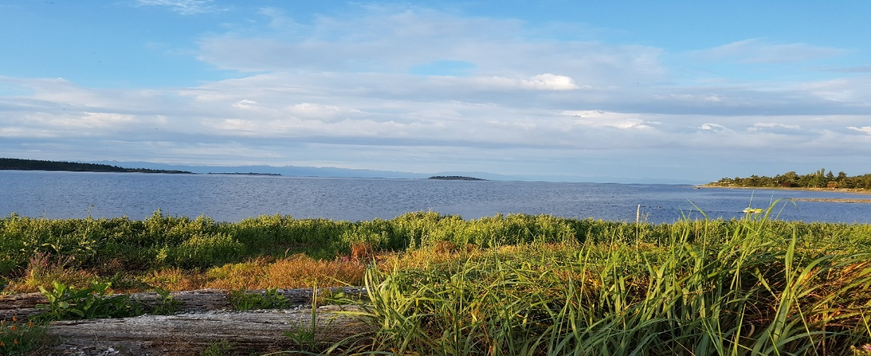
Hul’quimi’num Greeting or Phrase of the Week
‘Ii ch’ o uy’ al’ How are you? “I tsun o’ uy’ al I am fine
Tthiwhum please Hay chqa thankyou
Hul’quimi’num Animals
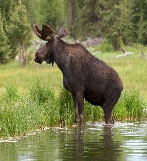
Moose q’uyi’uts (kie ee uts)

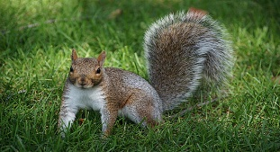Squirrel tth’upsiathun’ (t th up siathuns)
This Photo by Unknown Author is licensed under CC BY-NC-ND
Hul’quimi’num Body
Face …sa’ thu muqsun... nose
Eye …………………qulum’
Mouth…thathun yunus…. teeth

